**Run Spring Boot Application**

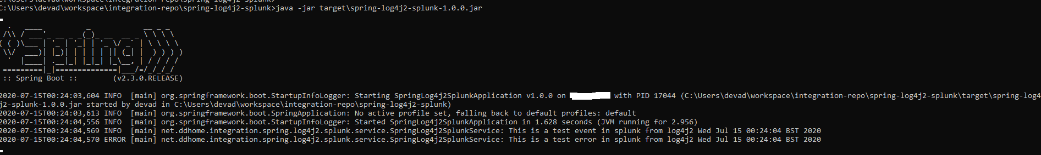

**Validate Splunk Index from Search & Reporting**

